Q1) Write a shell script to display the result “PASS” or “FAIL” using information given below:

Student Name, Student Registration Number, Marks1, Marks2, Marks3, Marks4. The minimum pass foreach subject is 50.

echo ' Student name '

read a

echo ' Student Registration Number '

read b

echo ' Student name :'$a

echo ' Student Registration Number :'$b

echo '********************************'

echo ' minimun pass for eacch subject is 50 '

echo '********************************'

echo ' mark1 '

read mark1

echo ' mark2 '

read mark2

echo ' mark3 '

read mark3

echo ' mark4 '

read mark4

echo '********************************'

if [ $mark1 -ge 50 -a $mark2 -ge 50 -a $mark3 -ge 50 -a $mark4 -ge 50 ]

then

echo ' you pass '

else

echo ' you fail '

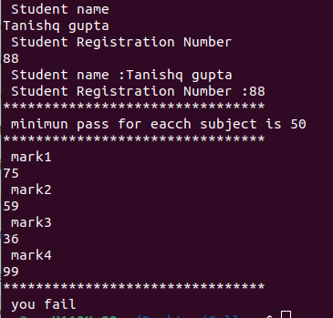fi

Q2) Write a shell script to accept temperature of city in Fahrenheit & convert the temperature into centigrade degrees.

echo -n "Enter temperature (F) : "

read tf

tc=$(echo "scale=2;(5/9)*($tf-32)"|bc)

echo "The conversion of Fahernite $tf to Celcius is :$tc"

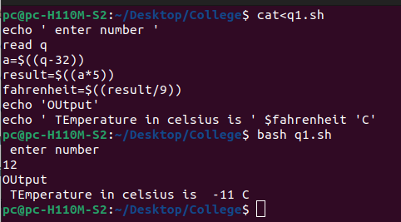

Q3) Write a program to print out all the Armstrong numbers between 1 & 500.

i=100

while [ $i -lt 500 ]

do

x=$i

sum=0

r=0

n=0

while [ $x -gt 0 ]

do

r=`expr $x % 10`

n=`expr $r \* $r \* $r`

sum=`expr $sum + $n`

x=`expr $x / 10`

done

if [ $sum -eq $i ]

then

echo $sum

fi

i=`expr $i + 1`

done

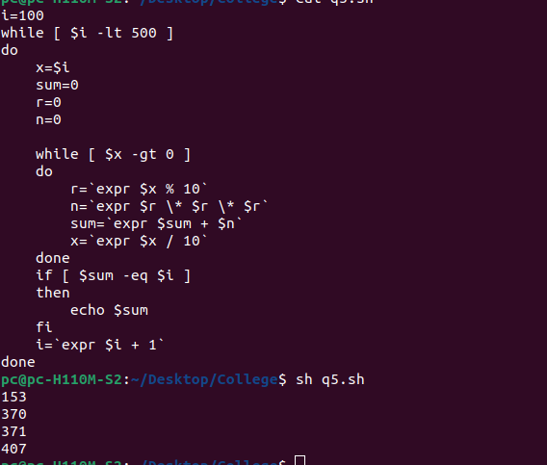

Q4) Write a shell script to generate all the combinations of 1,2 & 3 to form different numbers using for loop.

for i in 1 2 3

do

for j in 1 2 3

do

for k in 1 2 3

do

echo $i $j $k

done

done

done

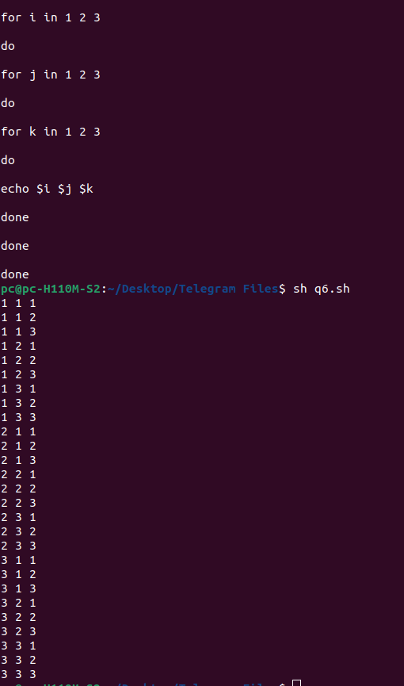

Q5) Write a shell script to calculate overtime pay of employees. Overtime is paid at the rate of 12,00 per hour for every hour worked above 40 hours. Assumption that employees do not worlk for fractional part of an hour.

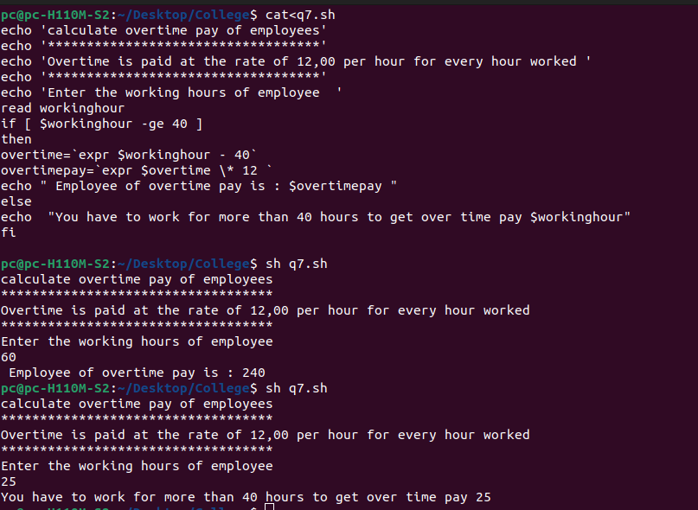

Q6) Write a shell script the determine whether the seller has made profit or incurred loss if the cost price & selling price of an item is inputted by the user? Also determine how much profit was made or loss incurred.

echo 'Enter the cost price of an item:'

read cost_price

echo 'Enter the selling price of an item:'

read selling_price

if [ $selling_price -gt $cost_price ]

then

result=`expr $selling_price - $cost_price`

echo "We earn $result profit by selling item."

elif [ $selling_price -lt $cost_price ]

then

result=`expr $selling_price - $cost_price`

echo "We incurred $result loss on selling item."

fi

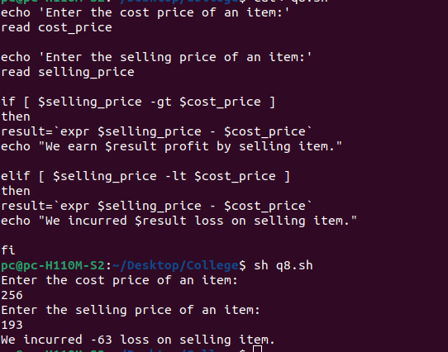

Q7) Write a shell script to calculate area & perimeter of the rectangle , area & circumference of circle if the length & breadth of a rectangle & radius of circle is inputted.

read -p "Enter the width and height of rectangle in meters: " width height

sqm=$(echo "$width * $height" | bc -l)

sqin=$(echo "$sqm * 1550" | bc -l)

echo "Area of the rectangle is: $sqm Square Meters or $sqin Square Inches."

echo "Enter the radious of the circle"

read r

area=$(echo "3.14*$r*$r" | bc )

circum=$(echo "3.14*2*$r" | bc)

echo "area of the circle is " $area

echo "circumference of the circle is " $circum

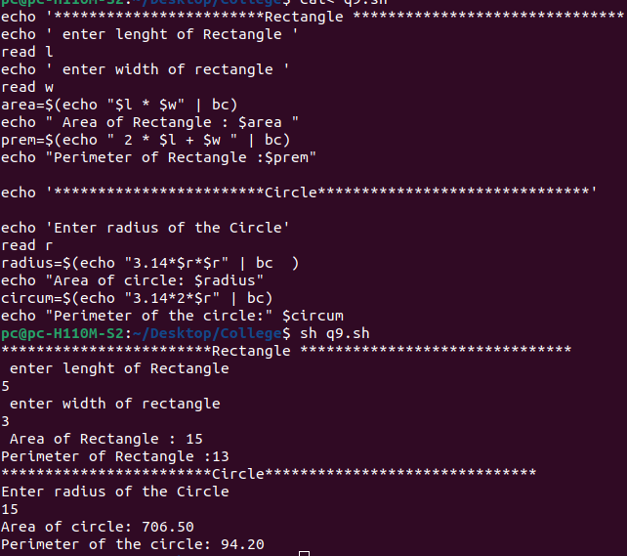

Q8) Write a program to check whether a number given by the user is zero, positive or negative.

echo ' Enter check whether a number given '

read number

if [ $number -gt 0 ]

then

echo ' Number is Positive :' $number

elif [ $number -lt 0 ]

then

echo ' Number is Negative. :' $number

else

echo ' Number is Equal : ' $number

fi

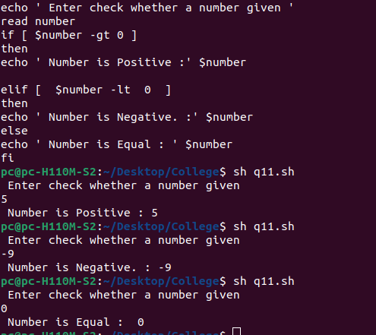

Q9) Write a shell script to input a number & print factorial of that number.

echo "Enter a number"

read num

fact=1

while [ $num -gt 1 ]

do

fact=$((fact * num))

num=$((num - 1))

done

echo $fact

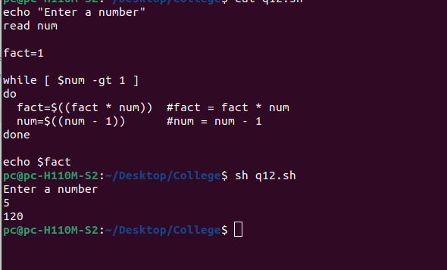

Q10) Write a program to display system date in format MM/DD/YY & system time is format hrs:min:secs.

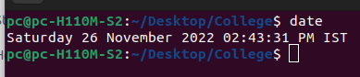



Q11) Write a shell script to find binary equivalent of a decimal number

read -p "Enter the num" n

val=0

power=1

while [ $n -ne 0 ]

do

r=`expr $n % 2`

val=`expr $r \* $power + $val`

power=`expr $power \* 10`

n=`expr $n \/ 2`

done

echo "Binary equivalent:=$val"

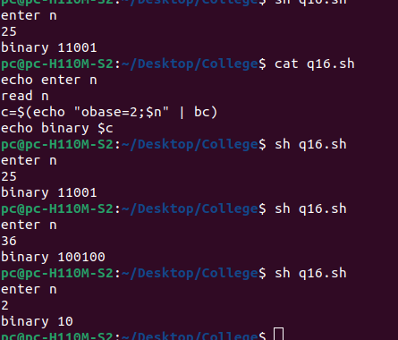

Q12) Write a shell script to display a three digit number in English words?

echo -n "Enter number : "

read n

len=$(echo $n | wc -c)

len=$(( $len - 1 ))

echo "Your number $n in words : "

i=1

while [ $i -le $len ]

do

digit=$(echo $n | cut -c $i)

case $digit in

0) echo -n "zero " ;;

1) echo -n "one " ;;

2) echo -n "two " ;;

3) echo -n "three " ;;

4) echo -n "four " ;;

5) echo -n "five " ;;

6) echo -n "six " ;;

7) echo -n "seven " ;;

8) echo -n "eight " ;;

9) echo -n "nine " ;;

esac

i=$((i+1))

done

echo ""

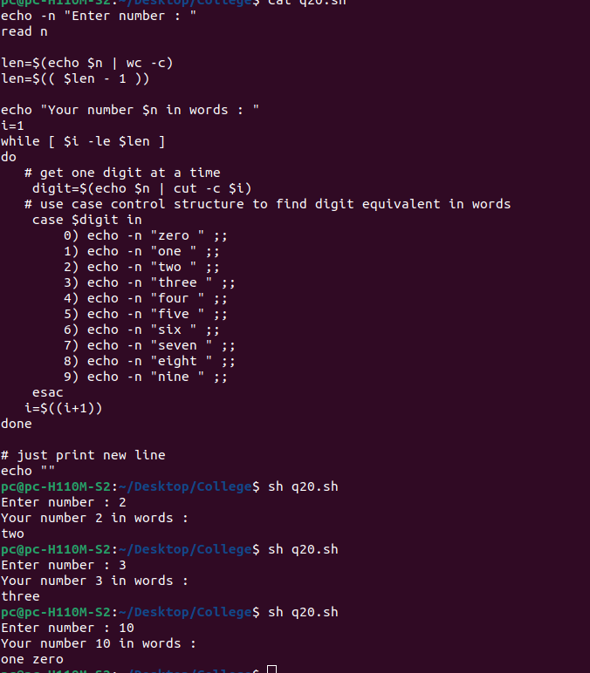

Q13) Write a shell script code to search a file in current directory?

echo "1.Display current dir"

echo "2.Listing the dir"

echo "Enter your choice"

read ch

case $ch in

1)echo "Current Dir is : "

pwd;;

2)echo "Directories are"

ls;;

*)echo "Invalid choice entered";;

esac

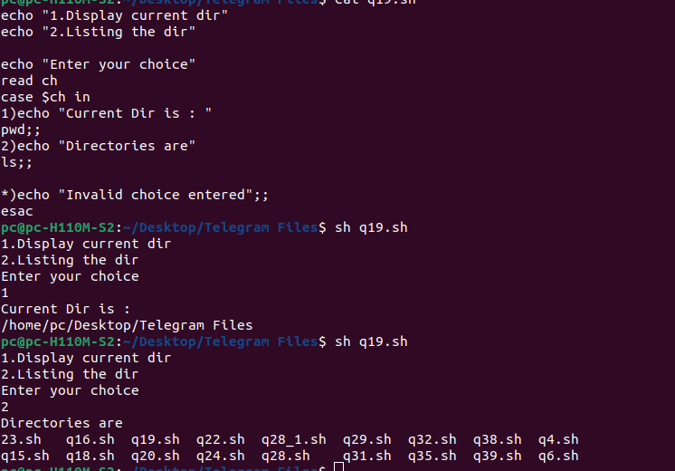

Q14) Write a shell script that accepts the input his or her weight. If the inputted weight is less than 80 kgs or more than 150 kgs he/she is welcomed in Wheeler club.

read -p "input his or her weight. " weight

if [ $weight -ge 150 -o $weight -le 80 ]

then

echo "welocme to the club"

else

echo "You are not welcomed "

fi

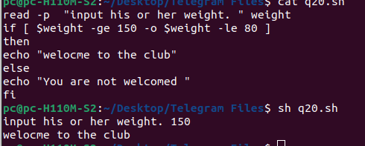

Q15) Write a shell script that accept the capital of Uttar Pradesh & repeats the question until the user gets it right.

answer="lucknow"

read -p ' Enter Capital of Uttar Pradesh: ' capital

if [ "$capital" = "$answer" ]

then

echo ' You Wins '

else

echo ' You lose '

fi

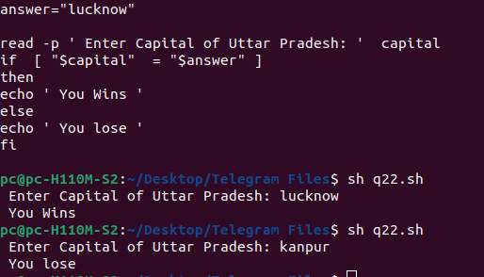

Q16) Write a shell script that takes a command-line argument & reports whether it is a directory, a file, or something else.

if [ -d $1 ]

then

echo "The provided argument is the directory."

elif [ -f $1 ]

then

echo "The provided argument is the file."

else

echo "The given argument does not exist on the file system."

fi

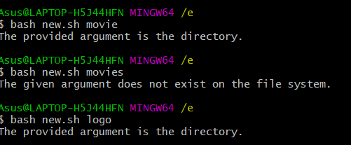

Q17) Write a shell script to find out what type of a character you have entered such as capital letter, digit, special symbol and whether you have entered more than one character.

i=1

while [ $i -le 10 ]

do

char=""

echo -n "Enter a one character : "

read char

if [ -z $(echo $char | sed -e 's/[0-9]//g') ]

then

echo "$char is Number/digit"

elif [ -z $(echo $char | sed -e 's/[A-Z]//g') ]

echo "$char is UPPER character"

elif [ -z $(echo $char | sed -e 's/[a-z]//g') ]

then

echo "$char is lower character"

else

echo "$char is Special symbol"

fi

i=$((i+1))

done

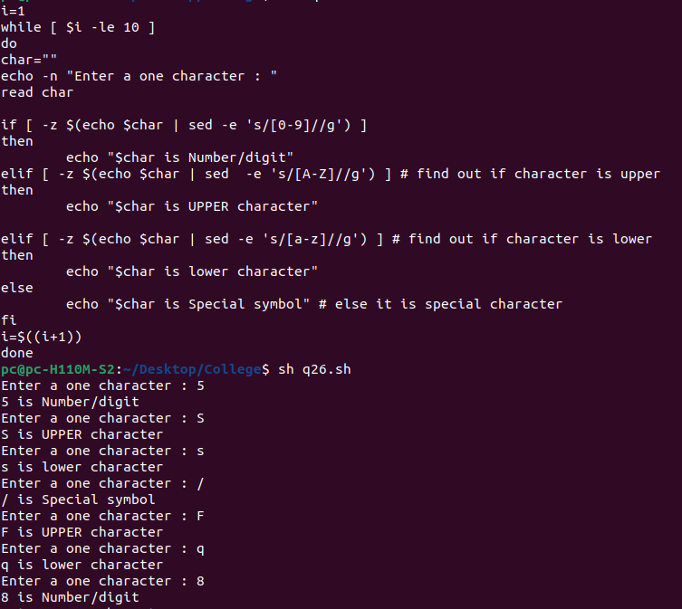

Q18) Write a script to find whether the file is writable or not. File name must be input by the user through command line.

echo -n "Enter file name : "

read file

# find out if file has write permission or not

[ -w $file ] && W="Write = yes" || W="Write = No"

echo "$file permissions"

echo "$W"

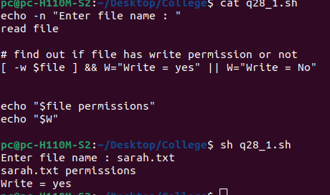

Q19) write a shell script to print the greatest number between three?

read ' Enter the first number ' a

read ' Enter the second number ' b

read ' Enter the third number ' c

if test $a -gt $b -a $a -gt $c

then

echo " $a is the greatest "

elif test $b -gt $c

then

echo " $b is the greatest "

else

echo " $c is the greatest "

fi

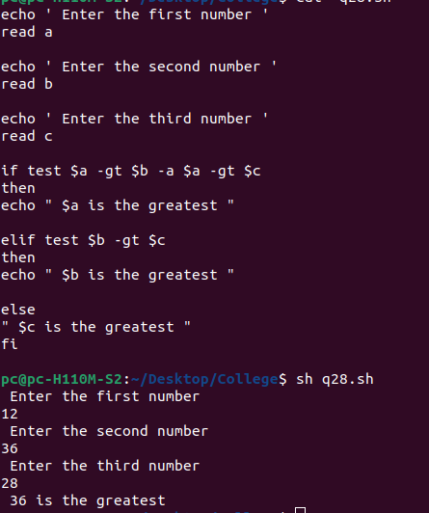

Q20) Write a shell script to find the greatest number, LCM for two given numbers.

echo "Enter two intergers"

read m n

echo " To find GCD and LCM"

echo "===================="

echo "given two numbers are"

echo "m= $m and n=$n"

temp=`expr $m \* $n`

while [ $m != $n ]

do

if [ $m -gt $n ]

then

m=`expr $m - $n`

else

n=`expr $n - $m`

fi

done

echo GCD=$n

lcm=`expr $temp / $n`

echo LCM=$lcm

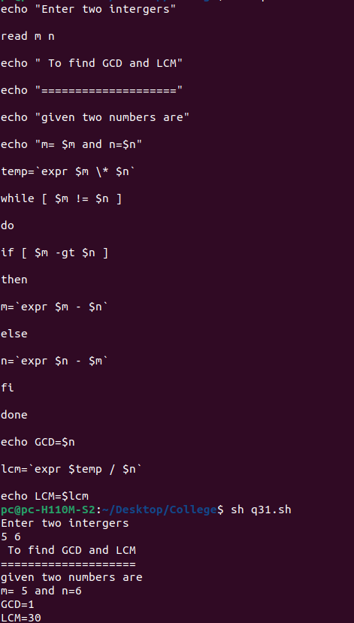



Q21) Write a shell script to print Fibonacci series up to a limit inputted by the user?

echo "Enter the value of n"

read n

a=0

b=1

count=2

echo "Fibonacci series:"

echo $a

echo $b

while [ $count -le $n ]

do

fib=`expr $a + $b`

a=$b

b=$fib

echo $fib

count=`expr $count + 1`

done

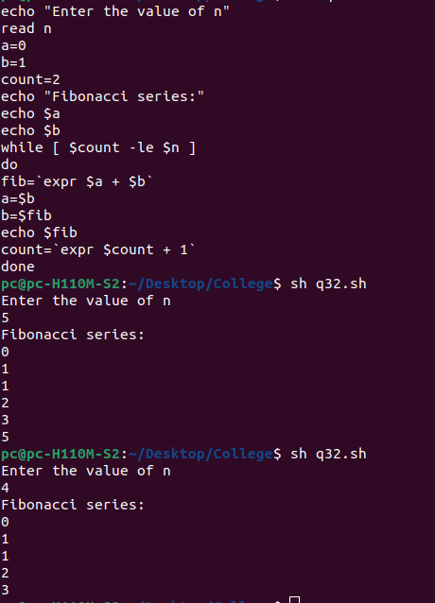

Q22) Write a shell script to find out the location of an input character into an input string.

read -p "Enter the main string: " str

read -p "Enter the substring :" sub

case $str in

*"$sub"*)

echo "String '$sub' is Present in the Main string ";;

esac

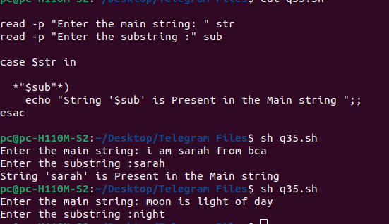

Q 23) Write a shell program that accepts the name of a file from the standard input & performs the following test on it:

i) File existence

ii) File readable

iii) File Writeable

iv) Both Readable & Writeable

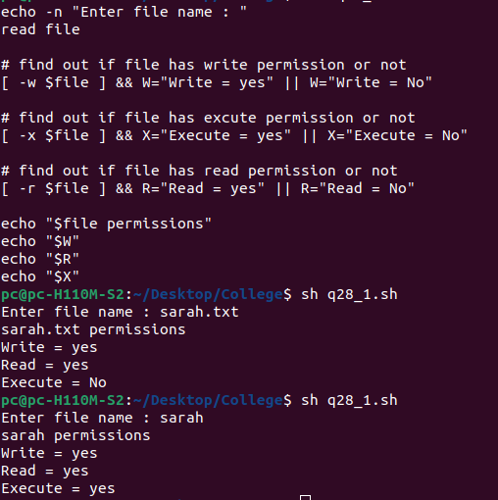

Q24) Write a shell program using 3 arguments to take the pattern as well as input & output file names. If the pattern is found “pattern found”, else display “Error message”. Also check if right number of arguments is entered.

ch=0

while [ $ch -ne 8 ]

do

echo '**************************************************'

echo "1.Copy a file"

echo "2.Rename file"

echo "3.Delete file"

echo "4.Edit file"

echo "Enter your choice"

read ch

case $ch in

1)echo "Enter filename from copy"

read f1

echo "Enter filenm2 to be copied"

read f2

cp $f1 $f2

echo $f2" is copied from "$f1;;

2)echo "Enter file name to rename"

read f1

echo "Enter new name of file"

read f2

mv $f1 $f2

echo $f1" is renamed as "$f2;;

3)echo "Enter any filenm to be delete"

read f1

rm $f1

echo $f1" is deleted";;

4)echo "Enter any file to be editing "

read f1

vi $f1;;

*)echo "Invalid choice entered";;

esac

echo '**************************************************'

done

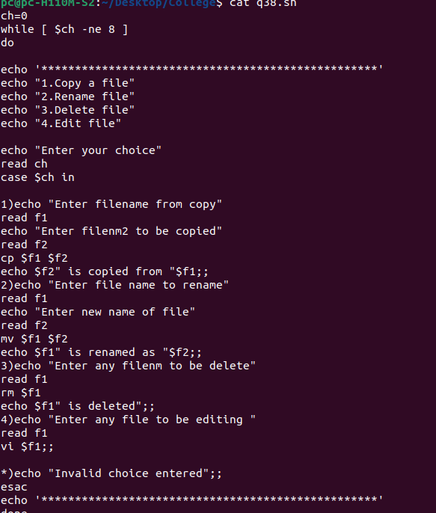

Q25) Write a menu driven shell program to copy, edit , rename & delete a file.

ch=0

while [ $ch -ne 8 ]

do

echo '**************************************************'

echo "1.Copy a file"

echo "2.Rename file"

echo "3.Delete file"

echo "4.Edit file"

echo "Enter your choice"

read ch

case $ch in

1)echo "Enter filename from copy"

read f1

echo "Enter filenm2 to be copied"

read f2

cp $f1 $f2

echo $f2" is copied from "$f1;;

2)echo "Enter file name to rename"

read f1

echo "Enter new name of file"

read f2

mv $f1 $f2

echo $f1" is renamed as "$f2;;

3)echo "Enter any filenm to be delete"

read f1

rm $f1

echo $f1" is deleted";;

4)echo "Enter any file to be editing "

read f1

vi $f1;;

*)echo "Invalid choice entered";;

esac

echo '**************************************************'

done

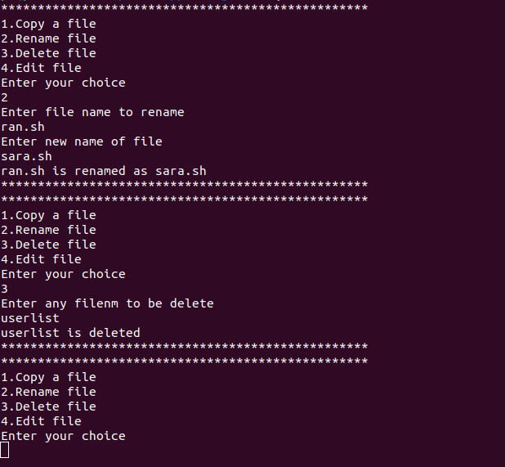

Q26) Write a menu driven Shell script for converting all the capital letters in a file to small case letters & vice versa.

getFile(){

echo -n "Enter File Name:"

read txtFileName

if [ ! -f $txtFileName ]; then

echo "File Name $txtFileName does not exists."

exit 1

fi

}

echo "1. Uppercase to Lowercase "

echo "2. Lowercase to Uppercase"

echo "3. Exit"

echo -n "Enter your Choice(1-3):"

read Ch

case "$Ch" in

1)

getFile

echo "Converting Upper-case to Lower-Case "

tr '[A-Z]' '[a-z]' <$txtFileName

;;

2)

getFile

echo "Converting Lower-Case to Upper-Case "

tr '[a-z]' '[A-Z]' <$txtFileName

;;

*)

echo "Exiting..."

exit

;;

esac

